GTAS Deploy Scenario

Date | Version | Description | Author
12 Apr 2008 | 1.0 | Initial draft | Tam Wei Xiang
07 Jan 2013 | 1.1 | Added section Using Proxy as incoming/outgoing transaction | Tam Wei Xiang

Table of Contents
1 DMZ Deployment 5
2 3 Tier - Clustering Deployment 6
3 Using Proxy for routing incoming/outgoing transaction 8
4 G-HOST 9
5 Normal Deployment 10
6 Reference 11

This document shows the different deployment scenario that GTAS has been configured to be run on them. Not all of the version of GTAS can be fit into the different scenario.

- DMZ Deployment
- Clustering Deployment
- Ghost Scenario (GTAS + GridMaster)
- Using Proxy for routing incoming/outgoing transaction
- Normal deployment

DMZ Deployment

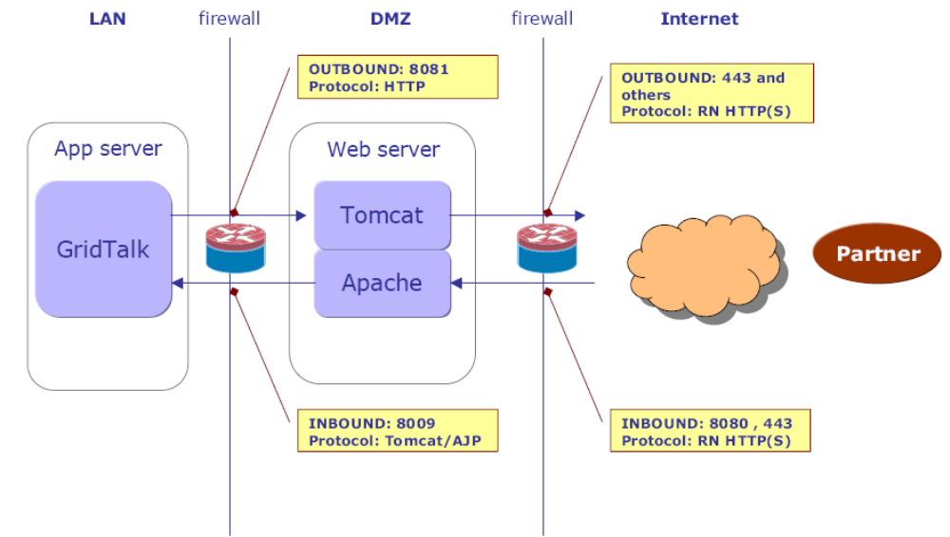

The above figure describes a typical deployment with the transport module (base-transport.war) residing in the DMZ in the Web server and GridTalk running in the internal network on the App server.
The internal firewall restricts connections from the Internet into the local network. Any connections to the LAN must originate from the DMZ and not from the Internet.
In the Web server, we have Tomcat and Apache running at the same time. Apache routes inbound connections and Tomcat routes outbound connections. They are configured to listen separate ports – Tomcat listens on port 8081 and Apache listens on port 8080.

Such a deployment adds another layer of security to the internal network resources since the outsider can only access the resources in the DMZ.

Refer to \\nas-etrade\releases_prd\gridtalk\DMZ\DMZConfigurationfor-GT42x.doc for the setup guide.

3 Tier - Clustering Deployment
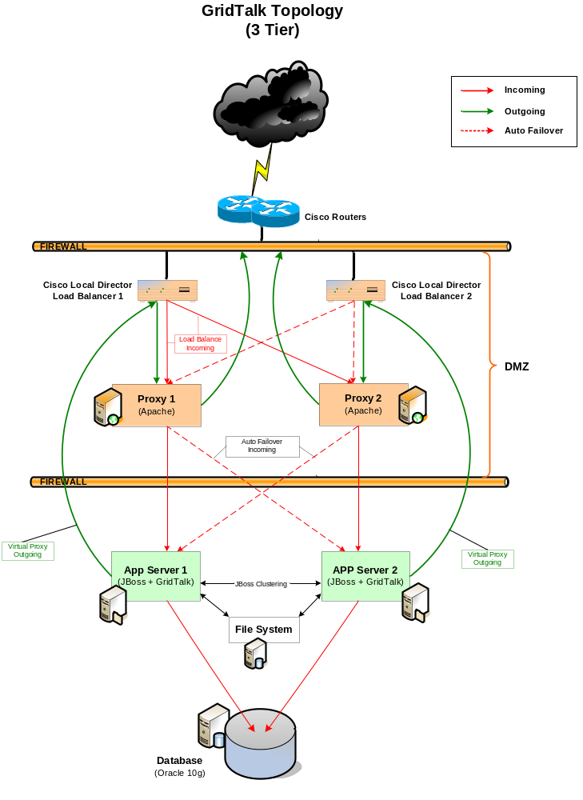
Presentation tier: Web Browser (GT WEB GUI + TXMR GUI)
Logic Tier: RNIF, AS2 Processing
Data Tier: File System & Database
Figure 1 GridTalk Topology
Figure 1 shows network topology for setting up GridTalk in cluster mode. The functions of the various components are as follow:-
- Cisco Local Director – Hardware load balancer that will dispatch the HTTP requests to the proxy servers in a round-robin fashion.
- Proxy – A software proxy server that function as HTTP proxy for both incoming and outgoing HTTP requests. The proxy server also functions as a fail-over mechanism in the event when it’s primary APP server is down.
- APP Server – The Application Server e.g. JBoss Application Server with GridTalk deployed. JBoss comes with an embedded Web-server, Tomcat web-server, which will service the HTTP requests coming into the APP server.
NOTE: Compare to the DMZ setup in section 1, the base-transport module of the GT still deployed in the JBOSS AS.
- File System – Shared file storage for storing configuration file and data files that are used by GridTalk.
- Database – Database for GridTalk and JBoss.

Each Proxy Server is paired up with an APP server (e.g. Proxy 1 to APP server 1 and Proxy 2 to APP server 2). APP server 1 is referred to as the primary server for Proxy 1. Proxy 1 will forward all HTTP request to APP server 1.

Currently, only GT4.1.X can support the above deployment scenario.

Using Proxy for routing incoming/outgoing transaction
For eBG, we are using Apache server as reverse/forward proxy to route incoming/outgoing transaction into GridTalk. It is similar to the Clustering deployment in the previous section.

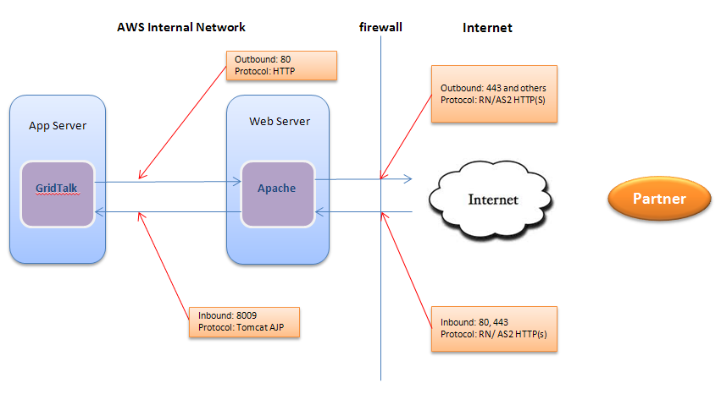

Refer to \\icon.crimsonlogic.com\div6\etrade\Technical\Support\EBG\ApplicationManagement for the power point slide of the eBG network topology

G-HOST
The following diagram depicts the information flow between GTAS Adapter and other components:
GHost

MESSAGING BUS
GTAS
Internet
EJB
GTAS ADAPTER
COMMAND CENTER
Point-to-point
Pub/Sub
…
User procedure
Alerts

GTAS is acted as the RNIF gateway to the GridMaster.

Normal Deployment
Depending on the network configuration setup by the customer, GTAS can expose to the public network directly or hide behind a firewall.

Reference
\\nas-etrade\releases_prd\gridtalk\DMZ\GridTalk-2.4-NetworkConfig.pdf
\\nas-etrade\releases_prd\gridtalk\GT41X\GT410\GridTalk Deployment Guide-v0.3.doc

